**CSS Assignment**

**Q.1. What are the benefits of using CSS?**

**A-** Benefits of CSS:-

1. Faster page speed.

2. Better user experience.

3. Quicker development time.

4. Easy formatting changes.

5. Compatibility across devices.

**-------------------------------------------------------------------------------------------------------------------------------------**

**Q.2. What are the disadvantages of CSS?**

**A-** Disadvantages of CSS:-

1.1.confusion due to many CSS levels.

2.Cross browser issues.

3. Security issues.

4. Extra work for developers.

**-------------------------------------------------------------------------------------------------------------------------------------**

**Q.3. What is the difference between CSS2 and CSS3?**

**A-** Difference between CSS2 and CSS3

|  |  |
| --- | --- |
| **CSS2** | **CSS3** |
| **1.** It specifies insingle document.  2. It is more than CSS.  3. It has web safe fonts.  4. It has simple selectors.  5. It does not have split text features.  6. It does not have grid system and template layout. | **1.** It divided into individual modules.  2. It is long along with the support for animations.  3. It has special fonts analogous to Google fonts and typecast.  4. It has a sequence of simple selectors.  5.It has split text features.  6. It has grid system and template layout. |

**------------------------------------------------------------------------------------------------------------------------------------**

**Q.4. Name a few CSS style components.**

**A-** The components of CSS style are-

1. Selector- selectors which has class name, id name or element name that is target.

2.Attribute- Name of the attribute you want to style e.g. border, color, background, position etc.

3. Value- value that will be assigned to attribute.

-------------------------------------------------------------------------------------------------------------------------------------

**Q.5. What do you understand by CSS opacity?**

**A-**  Opacity is the degree to which content behind an element is hidden and is the opposite of transparency. It sets within the number range 0.0 to 1.0 or in the percentage within 0% to 100%. To change the opacity of a background only use the background property with a color value.

e.g. opacity: value;

<!DOCTYPE html>

<html lang="en">

<head>

<meta charset="UTF-8">

<meta http-equiv="X-UA-Compatible" content="IE=edge">

<meta name="viewport" content="width=device-width, initial-scale=1.0">

<title>Document</title>

<style>

*{

margin: 0;

padding 0;

box-sizing: border-box;

}

#one{

height: 300px;

width: 100%;

background-image:url(https://images.unsplash.com/reserve/bOvf94dPRxWu0u3QsPjF_tree.jpg?ixlib=rb-4.0.3&ixid=MnwxMjA3fDB8MHxzZWFyY2h8M3x8bmF0dXJhbHxlbnwwfHwwfHw%3D&auto=format&fit=crop&w=500&q=60);

background-repeat: no-repeat;

}

#two{

height: 300px;

width: 100%;

background-image: url(https://images.unsplash.com/reserve/bOvf94dPRxWu0u3QsPjF_tree.jpg?ixlib=rb-4.0.3&ixid=MnwxMjA3fDB8MHxzZWFyY2h8M3x8bmF0dXJhbHxlbnwwfHwwfHw%3D&auto=format&fit=crop&w=500&q=60);

background-repeat: no-repeat;

opacity: 0.4;

}

</style>

</head>

<body>

<div id="one"></div>

<p>After applying opacity</p>

<div id="two"></div>

</body>

</html>

**Output:-**

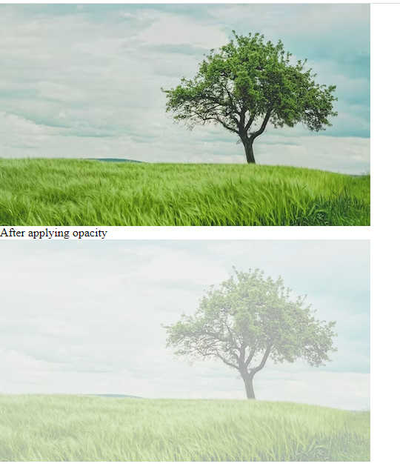

**-------------------------------------------------------------------------------------------------------------------------------------**

**Q.6. How can the background color of an element be changed?**

**A-** Background color of an element can be changed by using background-color property with its value. The background of an element is the total size of the element, including padding and border.

Syntax-

Background-color: color;

**e.g.**

<!DOCTYPE html>

<html lang="en">

<head>

<meta charset="UTF-8">

<meta http-equiv="X-UA-Compatible" content="IE=edge">

<meta name="viewport" content="width=device-width, initial-scale=1.0">

<title>Document</title>

<link rel="stylesheet" href="one.css">

<style>

h1,h2{

background-color: aqua;

}

</style>

</head>

<body>

<h1>abc</h1>

<h2>xyz</h2>

</body>

</html>

**Output:-**

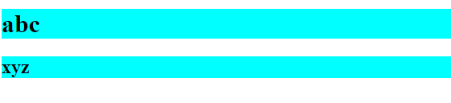

-------------------------------------------------------------------------------------------------------------------------------------

**Q.7. How can image repetition of the backup be controlled?**

**A-** The background-repeat property can be set to controlled of an image repetition. By default a background image is repeated both vertically and horizontally. To avoid the repetition of background image, we can set background-repeat property with value ‘no repeat’.

e.g. background-repeat: no repeat;

**e.g.**

<!DOCTYPE html>

<html lang="en">

<head>

<meta charset="UTF-8">

<meta http-equiv="X-UA-Compatible" content="IE=edge">

<meta name="viewport" content="width=device-width, initial-scale=1.0">

<title>Document</title>

<style>

*{

margin: 0;

padding 0;

box-sizing: border-box;

}

#one{

height: 500px;

width: 100%;

background-image: url(https://images.unsplash.com/reserve/bOvf94dPRxWu0u3QsPjF_tree.jpg?ixlib=rb-4.0.3&ixid=MnwxMjA3fDB8MHxzZWFyY2h8M3x8bmF0dXJhbHxlbnwwfHwwfHw%3D&auto=format&fit=crop&w=500&q=60);

}

#two{

height: 500px;

width: 500px;

background-image: url(https://images.unsplash.com/reserve/bOvf94dPRxWu0u3QsPjF_tree.jpg?ixlib=rb-4.0.3&ixid=MnwxMjA3fDB8MHxzZWFyY2h8M3x8bmF0dXJhbHxlbnwwfHwwfHw%3D&auto=format&fit=crop&w=500&q=60);

background-repeat: no-repeat;

}

</style>

</head>

<body>

<div id="one"></div>

<p>after controlling background repetition</p>

<div id="two"></div>

</body>

</html>

**Output:-**

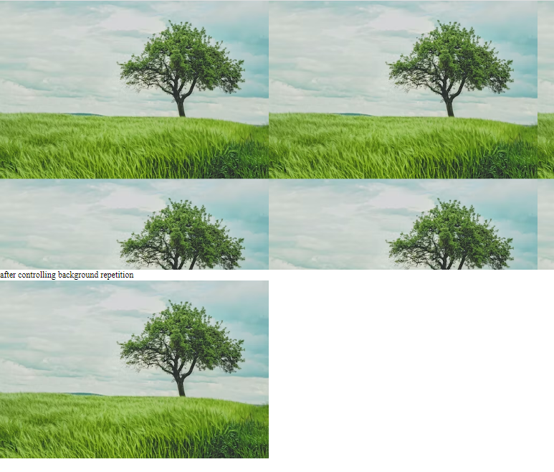

-------------------------------------------------------------------------------------------------------------------------------------

**Q.8. What is the use of the background position property?**

**A-** The background-position property sets the starting position of a background image. By default, a background image is placed at top-left corner of an element, and repeated both vertically and horizontally.

Syntax:

Background-position: value;

e.g.

<!DOCTYPE html>

<html lang="en">

<head>

<meta charset="UTF-8">

<meta http-equiv="X-UA-Compatible" content="IE=edge">

<meta name="viewport" content="width=device-width, initial-scale=1.0">

<title>Document</title>

<style>

div{

height: 50px;

background-color: rgb(0, 255, 204, 0.394);

position: sticky;

top: 0;

}

p{

height: 20px;

width: 20px;

background-color: red;

position: fixed;

top: 500px;

left: 80%;

}

</style>

</head>

<body>

<div></div>

Lorem ipsum dolor, sit amet consectetur adipisicing elit. Ipsam tenetur pariatur quia? Nostrum nulla provident sapiente odio ex ullam sequi accusamus recusandae veniam placeat quisquam porro illum, ut incidunt vero explicabo eius ipsa iste? Sed officiis nulla quasi similique tempora neque, ean perferendis doloremque temporibus! Ab fuga, nisi voluptas eos earum totam. <p></p>

</body>

</html>

**Output:-**

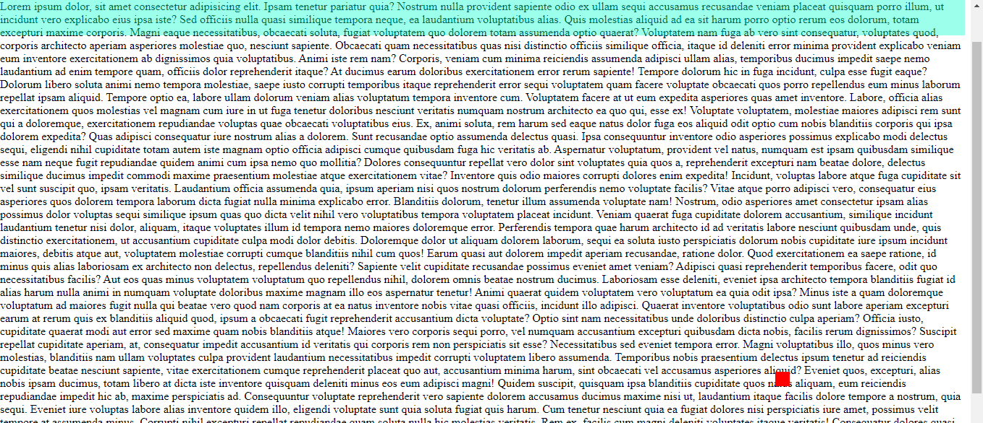

**----------------------------------------------------------------------------------------------------------------------------------**

**Q.9. Which property controls the image scroll in the background?**

**A-** The background-attachment property sets whether a background image scrolls with the rest of the page or is fixed.

Syntax:

Background-attachment: value;

**e.g.**

<!DOCTYPE html>

<html lang="en">

<head>

<meta charset="UTF-8">

<meta http-equiv="X-UA-Compatible" content="IE=edge">

<meta name="viewport" content="width=device-width, initial-scale=1.0">

<title>Document</title>

<style>

*{

margin: 0%;

padding: 0%;

}

div{

height: 100px;

width: 100px;

border: 2px solid red;

}

p{

height: 70px;

width: 70;

border: 2px solid black;

padding-top: 20px;

}

#one{

background-image: url(https://img.freepik.com/premium-vector/blue-abstract-background-with-mandalas_1159-956.jpg?w=740);

margin: auto;

padding: auto;

border: 2px solid black;

outline-offset: 20px;

overflow: scroll;

}

</style>

</head>

<body>

<div id="one">

<p>Lorem ipsum dolor sit amet consectetur adipisicing elit. Adipisci laudantium et reiciendis velit numquam, veritatis cum ad! Commodi soluta quam voluptatum alias, laborum recusandae nihil, animi dolores, iusto rerum autem.</p>

</div>

</body>

</html>

**Output:-**

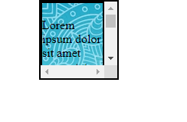

**-------------------------------------------------------------------------------------------------------------------------------------**

**Q.10. Why should background and color be used as separate properties?**

**A-**  Color is an inherited property while the background is not. The background property is a complex property in CSS and if it is combined with color, the complexity will further increase.

e.g.

<!DOCTYPE html>

<html lang="en">

<head>

<meta charset="UTF-8">

<meta http-equiv="X-UA-Compatible" content="IE=edge">

<meta name="viewport" content="width=device-width, initial-scale=1.0">

<title>Document</title>

<style>

body{

background-color: aqua;

}

h1{

color: blueviolet;

margin-left: 30px;

}

</style>

</head>

<body>

<h1>This is heading.</h1>

</body>

</html>

**Output:-**



**-------------------------------------------------------------------------------------------------------------------------------------**

**Q.11. How to center block elements using CSS1?**

**A-**  The <center> tag is used to center block elements. All the elements within the <center> tag will be centrally aligned.

e.g.

<!DOCTYPE html>

<html lang="en">

<head>

<meta charset="UTF-8">

<meta http-equiv="X-UA-Compatible" content="IE=edge">

<meta name="viewport" content="width=device-width, initial-scale=1.0">

<title>Document</title>

<style>

*{

margin: 0;

padding: 0;

box-sizing: border-box;

}

#one{

height: 300px;

width: 100%;

background-color: aqua;

}

h1{

color: blueviolet;

}

</style>

</head>

<body>

<center>

<div id="one">

<h1>Block Element</h1>

</div>

</center>

</body>

</html>

**Output:-**



**-------------------------------------------------------------------------------------------------------------------------------------**

**Q.12. How to maintain the CSS specifications?**

**A-** The CSS specification defines how CSS properties should be implemented bybrowser vendors along with detailed algorithms, code samples and tabular information.

The specification also includes:

1. The syntax and data types of the language.
2. Detailed explanation on CSS selectors
3. How you can assign values to properties.
4. The cascade (the C in CSS).
5. How inheritance works.
6. The box model.

**-------------------------------------------------------------------------------------------------------------------------------------**

**Q.13. What are the ways to integrate CSS as a web page?**

**A-** There are three ways to integrate CSS as a web page.

1. Inline: HTML elements may have CSS applied to them via STYLE attribute.

2. Embedded: By placing the code in a STYLE element within the HEAD element.

3. Linked/imported: Place the CSS in an external file and link it via a link element.

**------------------------------------------------------------------------------------------------------------------------------------**

**Q.14. What is embedded style sheet?**

**A-** An embedded style sheet is a CSS style specification method used with HTML. It can embed the entire stylesheet in an HTML document by using the STYLE element.

**e.g.**

<!DOCTYPE html>

<html lang="en">

<head>

<meta charset="UTF-8">

<meta http-equiv="X-UA-Compatible" content="IE=edge">

<meta name="viewport" content="width=device-width, initial-scale=1.0">

<title>Document</title>

<style>

body{

background-color: aqua;

}

h1{

color: blueviolet;

margin-left: 30px;

}

</style>

</head>

<body>

<h1>This is heading.</h1>

</body>

</html>

**Output:-**



**-------------------------------------------------------------------------------------------------------------------------------------**

**Q.15. What are the external style sheets?**

**A-** To apply a rule to multiple pages, an external style is used. An external style sheet is a separate CSS file that can be accessed by creating a link within the head section of the webpage. Multiple webpages can use the same link to access the stylesheet. The link to an external style sheet is placed within head section of the page

e.g.

<!DOCTYPE html>

<html lang="en">

<head>

<meta charset="UTF-8">

<meta http-equiv="X-UA-Compatible" content="IE=edge">

<meta name="viewport" content="width=device-width, initial-scale=1.0">

<title>Document</title>

<link rel="stylesheet" href="one.css">

<style>

h1,h2{

background-color: aqua;

}

</style>

</head>

<body>

<h1>abc</h1>

<h2>xyz</h2>

</body>

</html>

.

**External Css Code:**

h1,h2{

background-color: violet;

}

**Output:-**

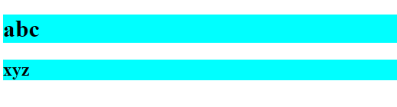

**-------------------------------------------------------------------------------------------------------------------------------------**

**Q.16. What are the advantages and disadvantages of using external style sheets?**

**A- Advantages of External style sheet:**

1. one change to the style sheet will change all linked pages.

2. You can create classes of styles that canthen be used on many different HTML elements.

3. Consistent look and feel across multipleweb pages.

4. Improved load times because the CSS file is downloaded once and applied to each relevant page as needed.

**Disadvantages of external style sheet:**

1. An extra download is essential to import style information for each file.

2.The execution of the file may be deferred till the external style sheet is loaded.

3.While implementing style shees, we need to test web pages with multiple browsers in order to check compatibility issues.

**-------------------------------------------------------------------------------------------------------------------------------------**

**Q.17. What is the meaning of the CSS Selectors?**

**A-** It is a string that identifies the elements to which a particular declaration apply. It is also referred as a link between the HTML document and the style sheet. It is equivalent of HTML elements. There are several different types of selectors in CSS.

1. CSS element selector- The element selector selects the HTML element by name.

e.g. <style>

P{ color : blue; }

</style>

2. CSS Id selector- The Id selector selects the id attribute of an HTML element to select a specific selement. It is written with the hash character ’#’, followed by the id of the element.

e.g. #one{

Background-color:red;}

3. CSS class selector- The class selector selects HTML element with a specific class attribute. It is used with a period character ‘.’ , followed by the class name.

e.g. .two{

Background-color:blue;}

4. CSS universal selector – The universal selector is used as a wildcard character. It selects all the elements on the pages.It defines with the ‘ *’ symbol.

e.g. *{

color: green;}

5. CSS group selector- The group selector is used to select all the elements with the same style definitions.

e.g. h1,h2,p{

Background-color: blue;}

**-------------------------------------------------------------------------------------------------------------------------------------**

**Q.18. What are the media types allowed by CSS?**

**A-** CSS media types are used in media queries, which allow you to apply different styles depending on the output device. It can use @media at-rule to create media queries that test for certain media types, then apply styles accordingly.

List of CSS media types:-

1. all – Matches all devices.
2. print – Matches printers, and devices intended to reproduce a printed display, such as a web browser showing a document in print preview.
3. screen – Matches all devices that arenot matches by print or speech.
4. speech – Matches screenreaders and other devices that read out the content of a page.

**e.g.**

<!DOCTYPE html>

<html lang="en">

<head>

<meta charset="UTF-8">

<meta http-equiv="X-UA-Compatible" content="IE=edge">

<meta name="viewport" content="width=device-width, initial-scale=1.0">

<title>Document</title>

<style>

/* *{

background-color: aqua;

} */

div{

height: 100vh;

width: 100%;

background-size: contain;

background-repeat: no-repeat;

background-image: url(https://images.unsplash.com/reserve/bOvf94dPRxWu0u3QsPjF_tree.jpg?ixlib=rb-4.0.3&ixid=MnwxMjA3fDB8MHxzZWFyY2h8M3x8bmF0dXJhbHxlbnwwfHwwfHw%3D&auto=format&fit=crop&w=500&q=60);

}

@media (min-width:320px) and (max-width:480px) {

div{

height: 100vh;

width: 100%;

background-size: contain;

background-repeat: no-repeat;

background-image: url(https://images.unsplash.com/reserve/bOvf94dPRxWu0u3QsPjF_tree.jpg?ixlib=rb-4.0.3&ixid=MnwxMjA3fDB8MHxzZWFyY2h8M3x8bmF0dXJhbHxlbnwwfHwwfHw%3D&auto=format&fit=crop&w=500&q=60);

}

}

</style>

</head>

<body>

<div></div>

</body>

</html>

**Output:-**

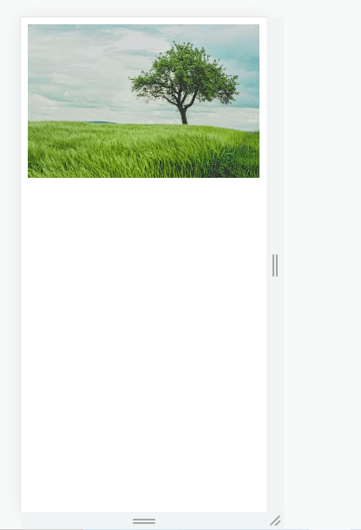

**-----------------------------------------------------------------------------------------------------------------------------------**

**Q. 19. What is the rule set?**

**A-** The ruleset is used to identfy that selectors can be attached with other selectors. It has two parts I.e.

1. selector – Selector indicates the HTML element you want to style.

2. Declaration block- The declaration block can contain one or more declarations separated by a semicolon.

e. g.

Selector{ property: value; }

**-------------------------------------------------------------------------------------------------------------------------------**

**Q.20. Create image gallery using display grid with responsive.**

**A-**

<!DOCTYPE html>

<html lang="en">

<head>

<meta charset="UTF-8">

<meta http-equiv="X-UA-Compatible" content="IE=edge">

<meta name="viewport" content="width=device-width, initial-scale=1.0">

<title>Document</title>

<style>

div{

display: grid;

grid-template-columns: repeat(8);

}

.two{

padding: 20px;

border: 10px solid black;

}

#one1{

height: 200px;

grid-column: 1/5;

background-image: url(https://encrypted-tbn0.gstatic.com/images?q=tbn:ANd9GcSCZlf5lc5tX-0gY-y94pGS0mQdL-D0lCH2OQ&usqp=CAU);

background-repeat: no-repeat;

background-size: cover;

}

#one2{

grid-column: 5/7;

background-image: url(https://encrypted-tbn0.gstatic.com/images?q=tbn:ANd9GcST76fI2nH14Q_Y2-Jx2Bq-ONPjeACsGB3g5g&usqp=CAU);

background-repeat: no-repeat;

background-size: cover;

}

#one3{

grid-column: 7/8;

grid-row: 1/8;

background-color: black;

}

#one4{

height: 200px;

grid-column: 1/3;

background-image: url(https://encrypted-tbn0.gstatic.com/images?q=tbn:ANd9GcSa_hQGG9IdgvDCWVOS4MMzvLCUJ0BvYPzfDQ&usqp=CAU);

background-repeat: no-repeat;

background-size: cover;

}

#one5{

grid-column: 3/6;

background-image: url(https://encrypted-tbn0.gstatic.com/images?q=tbn:ANd9GcRO-hlLa1mnf2V1p__dFMxkNjf44wHphOxH2g&usqp=CAU);

background-repeat: no-repeat;

background-size: cover;

}

#one6{

grid-column: 6/7;

background-image: url(https://encrypted-tbn0.gstatic.com/images?q=tbn:ANd9GcRO-hlLa1mnf2V1p__dFMxkNjf44wHphOxH2g&usqp=CAU);

background-repeat: no-repeat;

background-size: cover;

}

#one7{

height: 200px;

grid-column: 1/4;

background-image: url(https://encrypted-tbn0.gstatic.com/images?q=tbn:ANd9GcTaSlC5NEH60CTgwgBpXYJTI37o3jNNQImqhw&usqp=CAU);

background-repeat: no-repeat;

background-size: cover;

}

#one8{

grid-column: 4/7;

background-image: url(https://encrypted-tbn0.gstatic.com/images?q=tbn:ANd9GcRO-hlLa1mnf2V1p__dFMxkNjf44wHphOxH2g&usqp=CAU);

background-repeat: no-repeat;

background-size: cover;

}

#one9{

height: 100px;

grid-column: 1/3;

background-image: url(https://encrypted-tbn0.gstatic.com/images?q=tbn:ANd9GcSa_hQGG9IdgvDCWVOS4MMzvLCUJ0BvYPzfDQ&usqp=CAU);

background-repeat: no-repeat;

background-size: cover;

}

#one10{

grid-column: 3/5;

background-image: url(https://encrypted-tbn0.gstatic.com/images?q=tbn:ANd9GcST76fI2nH14Q_Y2-Jx2Bq-ONPjeACsGB3g5g&usqp=CAU);

background-repeat: no-repeat;

background-size: cover;

}

#one11{

grid-column: 5/7;

background-image: url(https://encrypted-tbn0.gstatic.com/images?q=tbn:ANd9GcSCZlf5lc5tX-0gY-y94pGS0mQdL-D0lCH2OQ&usqp=CAU);

background-repeat: no-repeat;

background-size: cover;

}

#one3-1{

height: 300px;

background-color: black;

}

h1{

color: white;

text-align: right;

}

a{

color: white;

text-align: right;

text-decoration: none;

}

</style>

</head>

<body>

<div >

<div class="two" id="one1"></div>

<div class="two" id="one2"></div>

<div class="two" id="one3">

<div id="one3-1">

<h1>SHUTTER</h1>

<a href="">HOME</a><a href="">PHOTOS</a>

<a href="">BIO</a><a href="">BLOG</a>

<a href="">CONTACT</a>

</div>

</div>

<div class="two" id="one4"></div>

<div class="two" id="one5"></div>

<div class="two" id="one6"></div>

<div class="two" id="one7"></div>

<div class="two" id="one8"></div>

<div class="two" id="one9"></div>

<div class="two" id="one10"></div>

<div class="two" id="one11"></div>

</div>

</body>

</html>

**Output:-**

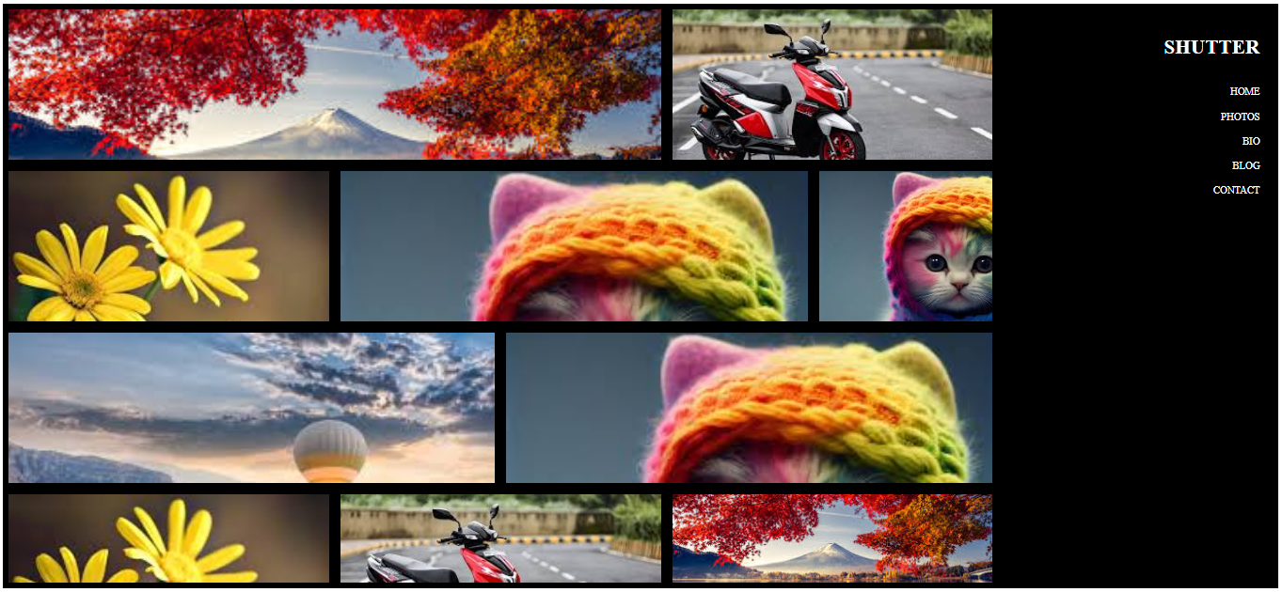

----------------------------------------------------------------------------------------------------------------------------------

**Q.21. Multiple background one side bg-color other side contain image as bg?**

**A-**

<!DOCTYPE html>

<html lang="en">

<head>

<meta charset="UTF-8">

<meta http-equiv="X-UA-Compatible" content="IE=edge">

<meta name="viewport" content="width=device-width, initial-scale=1.0">

<title>Document</title>

<style>

*{

margin: 0;

padding: 0;

box-sizing: border-box;

}

.container{

display: flex;

height: 768px;

width: 1071px;

background-color: #202020;

}

/* #one{

height: 800px;

width: 500px;

}

#two{

height: 800px;

width: 500px;

} */

img{

height: 768px;

width: 1071px;

position: relative;

left: 50%;

}

h1{

position: relative;

top: 70px;

left: 700px;

font-size: 36px;

letter-spacing: 4px;

color: #f4f5f9;

font-weight: 700;

font-family: source sans pro;

}

h2{

position: relative;

top: 130px;

left: 60%;

height: 74px;

width: 587px;

font-size: 18px;

line-height: 29px;

color: #e74c3c;

font-weight: 600;

font-family: open sans;

text-align: right;

}

p{

position: relative;

top: 100px;

left: 400px;

color: white;

text-align: right;

}

</style>

</head>

<body>

<div class="container">

<div id="one">

<h1>OUR SERVICES</h1>

<h2>Web Design</h2>

<p>Lorem ipsum dolor sit amet consectetur adipisicing elit. Laboriosam, recusandae animi? Quasi illo atque minima error exercitationem aspernatur iste tempore labore. Aliquid dolorem aut iste reprehenderit nemo eaque, nam provident.</p>

<h2>Print Design</h2>

<p>Lorem ipsum dolor sit amet consectetur adipisicing elit. Amet doloremque, fugit ratione nisi sunt illum? Laborum possimus libero pariatur inventore quis, ducimus atque in, velit deserunt blanditiis non dolorum ipsum.</p>

<h2>Photography</h2>

<p>Lorem ipsum dolor sit amet consectetur adipisicing elit. Incidunt dignissimos quia nobis dolorum, dolor facere magni sit est doloremque veritatis rerum excepturi, at consequatur delectus quibusdam quaerat. Explicabo, culpa ratione.</p>

</div>

<div id="two">

<img src="https://images.shiksha.com/mediadata/shikshaOnline/mailers/2021/naukri-learning/oct/27oct-v3/corporate-finance.jpg" alt="">

</div>

</div>

</body>

</html>

**Output:-**

**-------------------------------------------------------------------------------------------------------------------------------------**

**Q.22. Create Layout**

**A-**

<!DOCTYPE html>

<html lang="en">

<head>

<meta charset="UTF-8">

<meta http-equiv="X-UA-Compatible" content="IE=edge">

<meta name="viewport" content="width=device-width, initial-scale=1.0">

<title>Document</title>

<style>

*{

margin: 0;

padding: 0;

box-sizing: border-box;

}

/* Card style */

.card{

display: inline-block;

height: 300px;

position: relative;

top: 10px;

left: 20px;

width: 30%;

margin-inline: 10px;

border: 2px solid gray;

}

.one{

position: relative;

height: 130px;

padding: 40px;

background-color: rgba(12, 11, 11, 0.859);

color: white;

text-align: center;

}

p{

position: relative;

top: 10px;

padding: 10px;

text-align: justify;

}

button{

position: relative;

top: 30px;

left: 10px;

padding: 2px;

margin: 2px;

margin-inline: -2px;

}

/* 4th to 6th card */

.two{

position: relative;

top: -8px;

left: 75%;

}

.main-1{

position: relative;

top: 20px;

}

</style>

</head>

<body>

<!-- 1st to 3rd card -->

<div class="main">

<!-- card -->

<div class="card">

<div class="one">

<h1>Thumbnail</h1>

</div>

<div>

<p>Lorem ipsum dolor, sit amet consectetur adipisicing elit. Doloremque laborum consequatur facere vero, qui minus nobis itaque, unde magnam voluptas atque laudantium quisquam quia ab placeat saepe. Maiores, hic eum.</p>

<button>View</button>

<button>Edit</button>

<p class="two">Lorem</p>

</div>

</div>

<!-- Card-2 -->

<div class="card">

<div class="one">

<h1>Thumbnail</h1>

</div>

<div>

<p>Lorem ipsum dolor sit amet consectetur adipisicing elit. Aut quod adipisci quos eveniet, dolores aliquam itaque consequatur mollitia, quam nihil sint officiis, architecto rem inventore praesentium dolore aliquid quidem. Sed?</p>

<button>View</button>

<button>Edit</button>

<p class="two">Lorem</p>

</div>

</div>

<!-- card-3 -->

<div class="card">

<div class="one">

<h1>Thumbnail</h1>

</div>

<div>

<p>Lorem ipsum dolor sit amet consectetur adipisicing elit. Aut quod adipisci quos eveniet, dolores aliquam itaque consequatur mollitia, quam nihil sint officiis, architecto rem inventore praesentium dolore aliquid quidem. Sed?</p>

<button>View</button>

<button>Edit</button>

<p class="two">Lorem</p>

</div>

</div>

</div>

<!-- Card 4th to 6th -->

<div class="main-1">

<!-- card-4 -->

<div class="card">

<div class="one">

<h1>Thumbnail</h1>

</div>

<div>

<p>Lorem ipsum dolor sit amet consectetur adipisicing elit. Aut quod adipisci quos eveniet, dolores aliquam itaque consequatur mollitia, quam nihil sint officiis, architecto rem inventore praesentium dolore aliquid quidem. Sed?</p>

<button>View</button>

<button>Edit</button>

<p class="two">Lorem</p>

</div>

</div>

<!-- card-5 -->

<div class="card">

<div class="one">

<h1>Thumbnail</h1>

</div>

<div>

<p>Lorem ipsum dolor sit amet consectetur adipisicing elit. Aut quod adipisci quos eveniet, dolores aliquam itaque consequatur mollitia, quam nihil sint officiis, architecto rem inventore praesentium dolore aliquid quidem. Sed?</p>

<button>View</button>

<button>Edit</button>

<p class="two">Lorem</p>

</div>

</div>

<!-- card-6 -->

<div class="card">

<div class="one">

<h1>Thumbnail</h1>

</div>

<div>

<p>Lorem ipsum dolor sit amet consectetur adipisicing elit. Aut quod adipisci quos eveniet, dolores aliquam itaque consequatur mollitia, quam nihil sint officiis, architecto rem inventore praesentium dolore aliquid quidem. Sed?</p>

<button>View</button>

<button>Edit</button>

<p class="two">Lorem</p>

</div>

</div>

</div>

</body>

</html>

**Output:-**



